H.T No
Regulations:
A20

Sreenidhi Institute of Science and Technology
(An Autonomous Institution)
Code No: 8AC42 Date: 19-September-2024 (AN)

B.Tech I-Year I- Semester External Examination, September-2024 (Supplementary)
ELECTRICAL CIRCUITS AND NETWORK ANALYSIS (ECM)

Time: 3 Hours Max.Marks:70

Note: a) No additional answer sheets will be provided.
b) All sub-parts of a question must be answered at one place only, otherwise it will not be valued.
c) Missing data can be assumed suitably.

Bloom's Cognitive Levels of Learning (BCLL)

Remember | L1 | Apply | L3 | Evaluate | L5
Understand | L2 | Analyze | L4 | Create | L6

Part - A Max.Marks:20
Answer all QUESTIONS

 |  | BCLL | CO(s) | Marks
1 | State Kirchoff’s Voltage Law | L2 | CO1 | [2M]
2 | Define Resonance | L2 | CO2 | [2M]
3 | State Faraday’s Laws of Electro Magnetic Induction | L2 | CO3 | [2M]
4 | State Thevenin’s Theorem | L2 | CO4 | [2M]
5 | Write the symmetry and Reciprocity condition for Z parameters | L2 | CO5 | [2M]
6 | Obtain the s-domain equivalent of Inductor and Capacitor with zero initial condition | L3 | CO6 | [2M]
7 | Give examples of active and passive elements | L2 | CO1 | [2M]
8 | State Millimann’s Theorem | L2 | CO3 | [2M]
9 | Write h parameters in terms of Z parameters | L2 | CO5 | [2M]
10 | Write the average and effective values of V(t)=V_{m} sinwt | L2 | CO6 | [2M]
Part – B Max.Marks:50
ANSWER ANY FIVE QUESTIONS. EACH QUESTION CARRIES 10 MARKS.

 |  |  | BCLL | CO(s) | Marks
11. | a) | 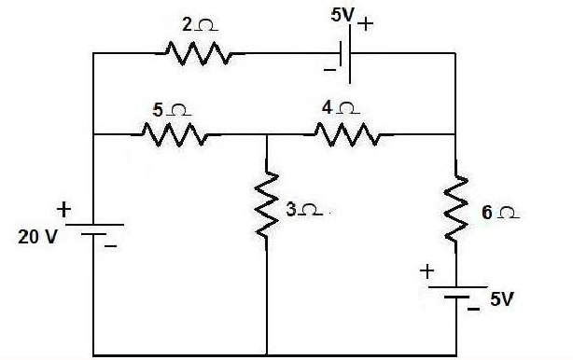Using Mesh analysis, find current through 4 ohm resistor | L3 | CO1 | [5M]
 | b) | Discuss about the basic R,L and C elements and write their voltage-current relationships. | L2 | CO1 | [5M]
12. | a) | A circuit consisting of three branches, Z₂ is in parallel with Z₃ the combination is in series with Z₁ having the values Z₁ =10+j30, Z₂ =5+j10and Z₃ = 4-j16 connected across single phase, 100 V, 50 Hz supply. Find i) I₁ , I₂ and I₃ ii) V₁ and V₂ | L3 | CO2 | [5M]
 | b) | Derive bandwidth for a series RLC circuit as a function of resonant frequency | L3 | CO2 | [5M]
13. | a) | Calculate the mutual inductance of two coils of self-inductances 100µH and 240µH, which are  connected in series to yield a total inductance of 146µH | L4 | CO3 | [5M]
 | b) | Compare Electric and magnetic Circuits | L2 | CO3 | [5M]
14. | a) | Find the value of RL so that maximum power is delivered to the load resistance shown in figure.  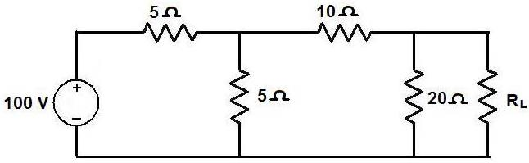 | L4 | CO4 | [5M]
 | b) | State Norton’s theorem and explain it with an example. | L3 | CO4 | [5M]
15. | a) | Find the Z- parameters for the following circuit  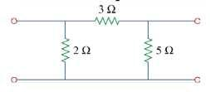 | L3 | CO5 | [5M]
 | b) | Express ABCD parameters in terms of h parameters | L3 | CO5 | [5M]
16. | a) | In the circuit shown in figure, switch S is in position 1 for a long time and brought to position 2 at time t=0.Determine the current.  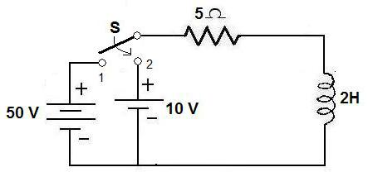 | L4 | CO6 | [5M]
 | b) | Derive the current expression for series R-L circuit for DC Excitation. | L4 | CO6 | [5M]
17. | a) | Find the current through each branch by network reduction technique | L3 | CO1 | [4M]
 | b) | Discuss the Steady State Analysis of series RL with Sinusoidal Excitation. | L3 | CO2 | [3M]
 | c) | Define and explain self and mutual inductance | L2 | CO3 | [3M]
18. | a) | State and explain Superposition theorem. | L2 | CO4 | [4M]
 | b) | Express Z parameters in terms of ABCD parameters | L3 | CO5 | [3M]
 | c) | Derive the current expression for series R-C circuit for DC Excitation. | L3 | CO6 | [3M]
-- 00 -- 00 –

